**WORKING LANDS FOR WILDLIFE**

**NORTHERN BOBWHITE, GRASSLANDS AND SAVANNAS**

**A Framework for Conservation Action**

**INTRODUCTION**

Grasslands of the U.S. (Figure 1), including forested savannas, have declined by over 90% with our nation’s demand for food and fiber sometimes outpacing our dual goal to conserve wildlife. The debate of whether these goals are compatible is succinctly captured as “spare or share” (Yale 2018): can effective and enduring conservation only be achieved by “sparing” or setting aside land, or can conservation occurring within larger “shared” working landscapes achieve similar goals? The answer is more nuanced, both are essential in real-world landscapes. Some of our rarest species and habitats are so sensitive and specific in their ideal conditions that setting aside land for their conservation is critical. Additionally, the most successful landscape scale restoration efforts often have a foundational “anchor” of well-managed land (usually government owned or managed) that serves to stabilize habitat availability year-to-year. Working Lands for Wildlife (WLFW) refers to these anchored work areas as Dynamic Landscapes, where conservation of private lands is mostly fluid over time but concentrated near stable habitat that serves to anchor wildlife populations. The Natural Resources Conservation Service (NRCS) manages several Farm Bill Conservation Programs that protect wetlands, forests, farms and ranches (<https://www.nrcs.usda.gov/wps/portal/nrcs/main/national/programs/easements/> ) and these can also serve as anchor sites in a Dynamic Landscape.

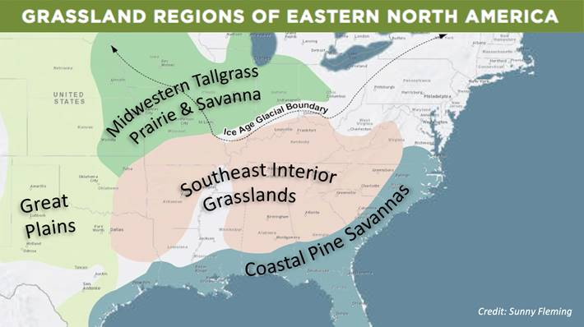

Figure 1. Southeastern Grasslands Initiative map of major grassland types across the U.S. Pine savannas and other smaller scale grassland types occur in the Northeast but are not depicted in this map.

But easements and fee title purchases are not always protective because landscape context, disease outbreaks, contaminants, and climate conditions can reach across ownership boundaries and deplete their value. We can’t buy or regulate our way to healthy landscapes as the financial and social costs are too high. That leaves us with the challenge of building shared visions with landowners and industries to identify conservation measures that are palatable to those controlling the land throughout much of the U.S. NRCS’s Working Lands for Wildlife (WLFW) is based on building shared visions with landowners and communities. In the geography for which this Framework for Conservation Action is developed (Figure 2), over 80% of the land ownership is private and in Texas that number rises to 95%. Private landowners make decisions based on a myriad of considerations, often economic ones. To create this 24-state Framework for Conservation Action, Working Lands for Wildlife staff and partners collaborated with corn, sorghum, cotton and peanut growers as well as livestock producers and forest landowners to identify which specific conservation practices met their objectives. We then consulted with natural resource experts and economists to identify those practices that achieved specific outcomes for wildlife conservation and climate resiliency, while also for increasing revenue and reducing financial risks for agricultural operations.

Figure 2. Map of priority areas for Working Lands for Wildlife Northern bobwhite, Grasslands, and Savannas

[Quote from forest landowner]

Working landscapes are an integral part of our national fabric. Success in achieving economic and conservation outcomes on working lands is among the biggest challenges of modern conservation. Many outside the agriculture community do not realize that economic pressures in recent years have led to increased suicide rates among ag producers and the number of family farms is declining annually. Landscape conservation designs that strategically integrate protected and working lands to support wildlife needs and economic realities have the most realistic chance of achieving long-standing conservation outcomes. WLFW builds common sense approaches sensitive to economic realities, providing key incentives while elevating the importance of land stewardship. The Northern bobwhite is a far-ranging species and land uses vary within and across state boundaries. Figure 3 depicts the primary land uses in the bobwhite range, within the 24 states participating in this initiative.

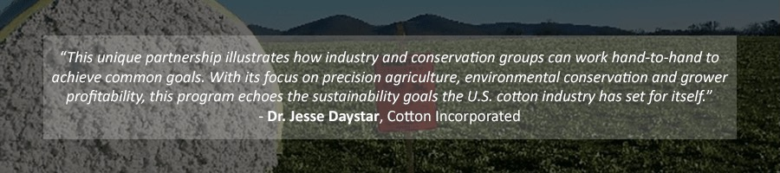

**RESOURCE CONCERNS**

Grasslands bird populations have followed the declining trends of their habitats, making habitat restoration and protection a key focus for their recovery. Grassland bird populations collectively have declined by 53%, or 720 million birds since 1970 (Rosenburg et al. 2019). Other faunal groups have also declined, and the Fish and Wildlife Service has listed over 20 as endangered or threatened to date. Biodiversity in the grasslands of the Southeast can be up to 20 times that of grasslands in other biomes of the country, making conservation of remnant grasslands in this region a high priority for floral and faunal biodiversity in the U.S. Though “conservation triage” (setting priorities in allocating species conservation funds) has been controversial in the past when considering how much to invest in preventing the extinction of a single endangered species, elevating that concept to triage approaches that invest in critical landscapes and wildlife communities has emerged (Bottrill et al. 2008) as a common sense approach to the practical problem of limited funds and staffing within the conservation agencies and larger partnerships.

The northern bobwhite quail was selected as a target species by NRCS state offices for good reason. Bobwhite are an umbrella or indicator species for the ecosystems in which they live, and research has shown “strong” associations with other grassland and shrubland birds. Crosby et al (2015) said “*Bobwhites were strongly associated with other grassland and shrubland birds and were a significant positive predictor for 9 species*.” They noted that seven of these, including Bell’s Vireo (*Vireo bellii*), Dicksissel (*Spiza americana*), and Grasshopper Sparrow (*Ammodramus savannarum*) have been designated by state wildlife agencies as species of conservation concern. Also, “*Species richness and occupancy probability of grassland and shrubland birds were higher relative to the overall bird community in sample units occupied by bobwhites. Our results show that bobwhites can act as an umbrella species for grassland and shrubland birds, although the specific species in any given situation will depend on region and management objectives. These results suggest that efficiency in conservation funding can be increased by using public interest in popular game species to leverage resources to meet multiple conservation objectives*.”

[pic of bobwhite - The Northern bobwhite quail is an iconic species in America. Generations of farmers, ranchers, families, and leaders in our country grew up hearing the distinctive “bob-WHITE” call and bonded over hunting excursions for quail. At its peak, bobwhite hunting was another revenue stream option in cash-strapped rural areas.]

Bobwhite quail have declined by over 80% in the past 30 years, which closely mirrors the decline of grasslands and savannas across its expansive range. Agriculture has been a major driver in converting grasslands to row crops or non-native pastures/rangelands and endemic forests to industrial forests - and agriculture can also be a significant driver in restoring habitats and populations. Bobwhite need a variety of habitats during their annual life cycle and to meet daily needs (e.g., foraging habitat, nesting cover, escape cover), and therefore restoring habitat for bobwhite quail will support biodiversity in these systems. Recovery actions for other at-risk species can easily be integrated into conservation plans for northern bobwhite, for example the monarch butterfly is often a co-beneficiary of these plans. And because the historic range of bobwhite (Figure 3) is so expansive, pursuing conservation goals for this species could result in collateral benefits to many and varied ag industries (e.g., Figure 4 depicts the geographic reach of row crop industries), hundreds of declining wildlife species, and include partnerships with significant numbers of historically under-served stakeholders [ask Martin for map?]. The range of northern bobwhite includes some of the poorest and most ethnically diverse rural areas of the U.S.

**Figure 4.** Major row crop production areas within Northern bobwhite priority areas.

Figure #. map of HUs? Ask Martin]

Figure 4. Cornell Lab of Ornithology map of Northern bobwhite distribution.

In May 2021, the **Journal of Wildlife Management** published a commentary (Williams et al. 2021) that argues for more federal leadership and investment in Northern bobwhite conservation. As a non-migratory game bird, the Northern bobwhite is not the beneficiary of federal coordination or expenditures to track population trends, set joint habitat or population targets, or develop collaborative regulation of hunting across the states, as is the case with migratory game birds. Furthermore, significant federal funds that are available for migratory species, non-game species, and rare species may not directly benefit bobwhite quail. As the pendulum in recent decades has swung away from a bias towards the conservation of game species, some game species like bobwhite have been left in limbo. Though steep populations declines are undisputed, it has often been hard for advocates of northern bobwhite conservation to be heard over other seemingly more pressing conservation emergencies. Though waiting until a crisis emerges places the chance of successfully recovering a species in jeopardy, inadequate conservation resources, litigation and regulatory drivers increasingly press conservation agencies into this exact situation. We need to get in front of this train instead of running behind it and well-planned habitat restoration that benefits a host of species at varying landscape scales is the way to do that.

**Figure #.** Breeding Bird Survey trends 2009-2020 reveal local trends in Northern bobwhite.

Several federal agencies including NRCS have be supporting northern bobwhite conservation for decades, and the state wildlife agencies whose mission includes conservation of non-migratory game species have made significant investments in bobwhite conservation planning and habitat management. Despite these significant and sustained efforts, there has been no change in the downward march of bobwhite populations, which led Quail Forever and the National Bobwhite Technical Committee (NBTC) to request in 2020 that NRCS elevate its role in northern bobwhite conservation. Importantly, this request was supported by letters from diverse ag producer organizations across the species’ range. In early 2021, NRCS released a National Bulletin (NB 300-21-14) entitled ***New enhancements to Working Lands for Wildlife - Northern bobwhite initiative: opportunities to strengthen the role of NRCS in grassland and savanna conservation*** ([**https://directives.sc.egov.usda.gov/ViewerFS.aspx?hid=46099**](https://directives.sc.egov.usda.gov/ViewerFS.aspx?hid=46099)) that details actions the agency committed to taking to enhance its involvement in and support of the National Bobwhite Conservation Initiative ([National Bobwhite Conservation Initiative - NBCI (bringbackbobwhites.org)](https://bringbackbobwhites.org/) and its goals. A key outcome of the National Bulletin is this this **Framework for Conservation Action** representing a cohesive plan by twenty-four NRCS state offices and their local partners to cooperate to increase the amount and effectiveness of conservation practices implemented through Farm Bill programs to benefit Northern bobwhite, grasslands, and savannas of the central and eastern U.S. Our hope is that the enhanced role of NRCS represented by this plan will serve the stated need for federal coordination for northern bobwhite conservation, as well as increase resources applied to conservation of grasslands and savannas.

**[Quote from Vincent, Director, QF]**

**FEATURED PARTNER: QF**

**[TEXT BOX w pic of farmer?:** Conservation partners working with limited budgets to address seemingly unlimited challenges must make hard choices in the same way a farmer or rancher does in managing their lands.]

Working Lands for Wildlife, NRCS focuses on limited habitat as well as other resource concerns that affect ag operations to achieve the desired “win-win” for ag producers. On page # you’ll find an assessment of the anticipated impact of WLFW-Northern bobwhite, Grasslands and Savannas on the economics of ag operations, dividing conservation practices into those that enhance revenue and mitigating financial risks.

“*We have been extremely pleased with the results of our habitat work in conjunction with NRCS. NRCS and Quail Forever did a great job explaining to us what our expectations should be from them and also what was expected from us throughout the program.  They were available anytime a question arose and simplified the process for first time program participants*.” Jantzen Brantley, Landowner, White Oak, NC

**FEATURED PARTNER: NBCI**

The **National Bobwhite Conservation Initiative** (NBCI) is a 27-year partnership comprised of 25 state wildlife agencies supported by a myriad of non-government organizations, federal agencies, and universities. The team focuses on grassland restoration and management to recover northern bobwhite and associated species while enhancing water quality, soil health, air quality, and human health and wellness. Throughout NBCI’s history, there has been an intense focus on private lands conservation particularly involving agricultural and timber production. The USDA Farm Bill has been at heart of those efforts. The Northern Bobwhite Working Lands for Wildlife Program represents the ideal conservation delivery mechanism for the NBCI’s strategic restoration approach outlined by the Coordinated Implementation Program (CIP). The program is designed to “learn while doing” through an elaborate monitoring program aimed at birds, habitat, and management. The CIP established goals and benchmarks over a 10-year timeline. By working in concert, states minimize their financial investment, but gain the power of replication for expedited and more reliable science through the NBCI. The adaptive management program is crafted to scale-up conservation practices from relatively small focus areas (approximately 5,000 acres) to landscapes (10,000’s of acres) and ultimately, regions (100,000’s of acres) based on lessons learned from each preceding tier. Efforts are underway to include the Integrated Monarch Monitoring Program in CIP focus areas, and they are reaching out to soil, water, and air research interests to overlap learning in these working lands laboratories.

[Partner Feature: NBTC]

**[Quote from Lisa Potter, NBTC Chair]**

**CONSERVATION NEEDS: The Diagnosis & Treatment Options**

Westwood et al. (2014) calls for conservation agencies to draw from established principles in medicine and introduced a 5-stage classification of recovery: diagnosis, treatment, stabilization, rehabilitation, and recovery. Medical terminology being more familiar to the general public, this classification allows conservation practitioners to talk about their work in a way that supersedes professional, technical or agency terms and jargon. So let’s talk about the “diagnosis” at both the macro (landscape) and micro (species and farms/ranches) scales.

At the landscape scale, Ross et al. (2021) uses 5 categories of threats to grassland species and ecosystems: (1) habitat loss, fragmentation, and disruption of functional connectivity; (2) climate change; (3) altered disturbance regimes; (4) invasive species; and (5) localized impacts. If we look at these through the lens of the national Farm Bill Conservation Programs, NRCS plans apply treatments for each of these causal factors.

**[Also create a text box to hi-lite these 5 threat categories! Primary Grassland/Savanna Threats: (1) habitat loss, fragmentation, and disruption of functional connectivity; (2) climate change; (3) altered disturbance regimes; (4) invasive species; and (5) localized impacts.]**

**Habitat Loss and Fragmentation**

WLFW will focus on restoration of native grasslands and savannas across the participating central and eastern states, and habitat connectivity through cropland. In the Fescue Belt (Figure 5) where 45 million acres have been converted to non-native grasses and dominated by tall fescue (*Festuca arundinacea*), the agency and its partners will work with producers to convert a portion of their grazing lands to native warm season grasses. The Fescue Belt comprises 10% of U.S. land area across the Mid-Atlantic, Upper-South and Lower Mid-West and has the highest concentration of livestock in the nation. Tall fescue is a cool season, perennial bunchgrass that became popular in the 1930s due to its ability to provide abundant forage. However, a toxic endophyte endemic to the plant is common and impacts livestock weight, reproduction and overall health. Fescue toxicity impacts over a quarter of the beef cows in the United States, resulting in estimated losses to the cattle industry over one billion dollars annually (Strickland et al. 2011). Improved cultivars are increasingly available to producers, but it’s expensive and challenging to attempt the conversion and no additional wildlife benefits are gained from it. WLFW will assist interested producers in establishing native warm season grass paddocks and prescribed grazing systems. Prescribed grazing is compatible with maintaining suitable habitat for northern bobwhite and is one of several tools to reduce over-growth or invasive vegetation that renders bobwhite habitat unsuitable.

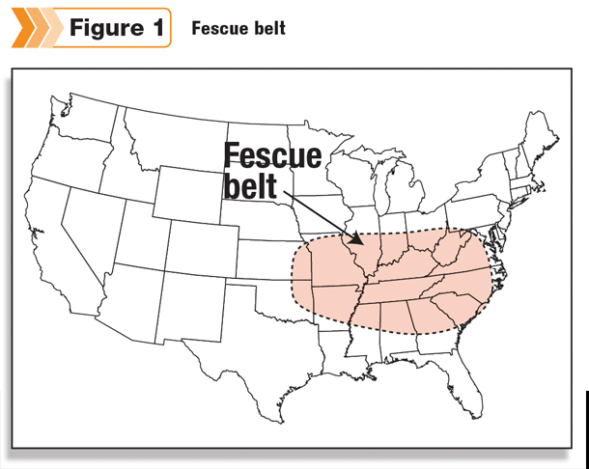

Figure 6. The Fescue Belt has the highest concentration of livestock producers in the U.S. and is dominated by tall fescue ((replacing this with an original USDA version soon)

Cool-season grass grow well in spring (April-early June) and fall (OctoberNovember). During summer, tall fescue growth slows, leading to a “summer slump” in forage production. Native warm season grasses like switchgrass, big bluestem, Indiangrass, and Eastern gamma can fill this forage gap and improve livestock health, while also benefiting wildlife. In 2019, NRCS released a Science to Solutions [Science-to-Solutions_NWSG-Forage-Economics-Quail_FINAL-DRAFT-v2-w-Table-Correction_Jan-2019-2.pdf (cpb-us-w2.wpmucdn.com)](https://cpb-us-w2.wpmucdn.com/u.osu.edu/dist/c/14592/files/2019/08/Science-to-Solutions_NWSG-Forage-Economics-Quail_FINAL-DRAFT-v2-w-Table-Correction_Jan-2019-2.pdf) summarizing the peer reviewed science reported by Keyser and Boyer (2018) on using native grasses as forage with comparison to tall fescue and other non-native grass varieties. Incorporating native warm season grasses into grazing systems can increase grazing days, reduce reliance on more costly hay and commodity feeds, and help improve fescue pastures by allowing them to rest during summer.

**Figure 5.** Cattle given the option to graze in native warm season pastures are healthier. Unlike most fescue, these pastures do not contain toxic endophytes and they provide abundant forage during hot seasons increasingly experienced across the U.S. due to climate change.

Landowner referring to native grass pastures he planted more than 25 years ago, "*this has been my best agricultural investment ever*!” C. Benhoff, Virginia

Savannas in the East can be dominated by one or several tree species including oak-hickory through the Midwest and into the Northeast, and several pine species, predominantly longleaf pine (*Pinus palustris*) in the Southeast. WLFW will focus on establishing more open canopies in unmanaged sites using predominantly prescribed burning and timber thinning plus several conservation practices that will focus on understory management for wildlife and improved timber production. Details are discussed under the **Altered Disturbance Regimes** and **Invasive Species** sections below.

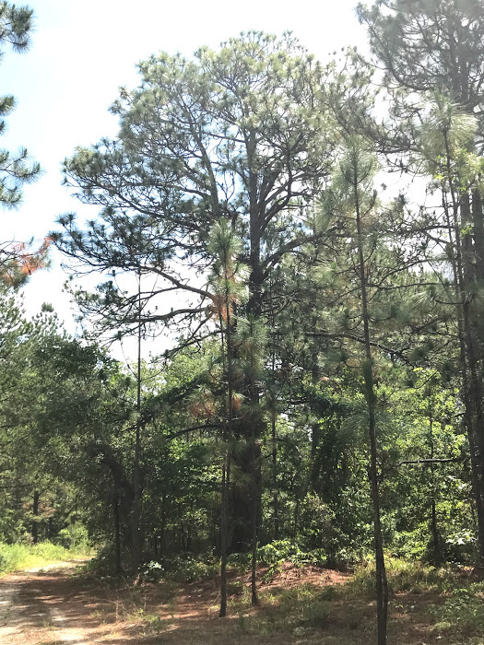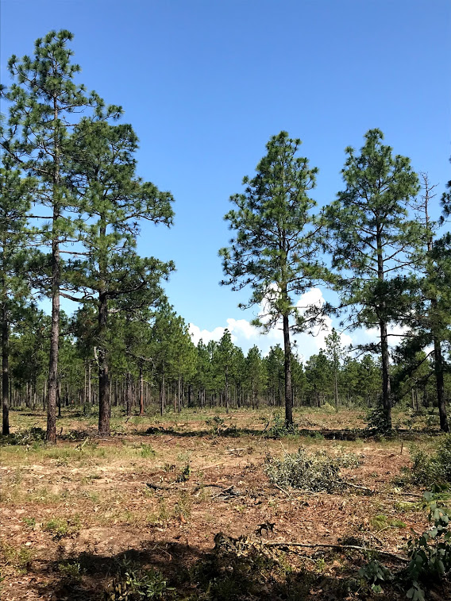

**BEFORE AFTER**

“*As a new landowner looking to develop a management strategy for quail and gopher tortoise, having the resources for funds and technical assistance has been most helpful. Being given a timeline specifically geared to manage my property, and knowing biologists are just a phone call away if I have questions has helped me in achieving my property goals*.” **Mr. Busby, Georgia** (property in pic BEFORE & AFTER).

NRCS is providing funding support and oversight to partners for completion of the **Southeast Longleaf Element Occurrence Geodatabase** (LEO GDB). The LEO GDB project goals are to produce: 1) a comprehensive ArcGIS geodatabase that will enable states and partners to view and analyze standardized longleaf map data at multiple scales from local to range-wide, and measure longleaf acres and vegetative condition changes through time, and 2) a rapid assessment protocol and mobile app for use in field data collection where information gaps are identified. Good progress has been made toward these goals and current products are available at [Southeast Longleaf - Florida Natural Areas Inventory (fnai.org)](https://www.fnai.org/species-communities/southeast-longleaf). The LEO GDB will support improved landscape restoration planning at scales needed to effectively and efficiently address habitat losses.

“*The Working Lands for Wildlife program provides vital support to private landowners who sustain 86% of the South’s more than 245 million forested acres,” said Scott Phillips, Southern Group of State Foresters (SGSF) Chair and South Carolina State Forester. “The program enables land stewards to keep forests, and key habitats, intact and healthy by helping landowners manage for forest conditions that benefit bobwhite quail and other wildlife, while also providing for economic returns*.” **Chelsea Ealum, Communications Director. Southern Group of State Foresters**

Producer groups representing sorghum, corn, soybeans, cotton, peanut, and poultry are all supporting this initiative and its efforts to employ conservation practices on marginal cropland or adjacent to fields to enhance habitat connectivity such as field borders, conservation cover, hedgerow plantings, and early successional habitat establishment. In addition, reduced tillage will control erosion, improve water quality and soil health, and retain moisture. Through Quail Forever, WLFW will begin hiring precision ag specialists in 2022 who will work with farmers to calculate the cost-benefit of continuing to farm marginal lands and suggest wildlife-friendly alternatives. In addition, WLFW is funding a range-wide assessment of precision ag and economic variables to identify areas of the country where there are concentrations of marginal ag land with the intent of providing more support to farmers in those areas. Because habitat connectivity is a key issue in the decline of many species, and especially species that have smaller home ranges, the participation of row crop farmers will be critical to the success of the partnership.

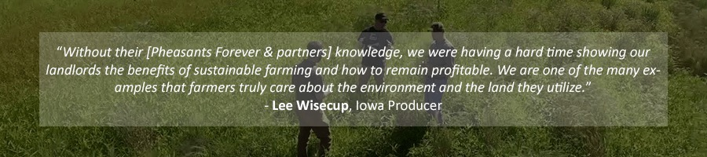

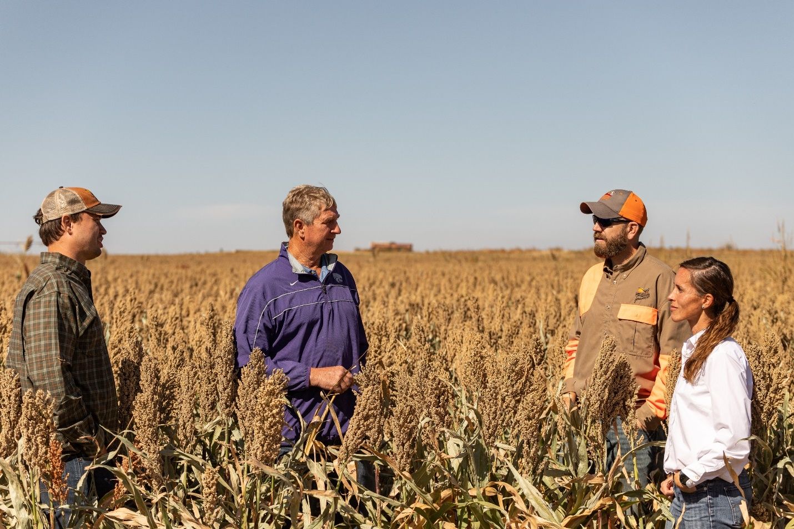

*Sorghum’s relationship with upland birds is unique and creates mutually beneficial opportunities for both wildlife conservation and farm profitability. These benefits present an ideal opportunity for strategic and targeted conservation efforts on working lands that can help maximize land productivity - both in terms of yields and dollars as well as in supporting ecosystem services*. **Kira Everhart-Valentin, Sustainability Director, United Sorghum Checkoff Program**

WLFW will also promote conservation practices and program options that offer financial alternatives to landowners. Among these will be increased availability of the Agricultural Conservation Easement Program to reimburse willing landowners for either 30-year or perpetual easements and expanded use of the Conservation Stewardship Program to reward landowners who demonstrate good stewardship of their lands with incentive payments.

**Climate Change**

Mawdsley et al (2009) found that addressing climate change was less an issue of developing new conservation practices and more one of targeting creative approaches to the most vulnerable landscapes and species. “*Although our review indicates natural resource managers already have many tools that can be used to address climate-change effects, managers will likely need to apply these tools in novel and innovative ways to meet the unprecedented challenges posed by climate change*.” WLFW is participating on a team of NRCS experts assessing the contributions of the agency’s over 400 conservation practices from our Field Office Technical Guide ([Field Office Technical Guide (FOTG) | NRCS (usda.gov)](https://www.nrcs.usda.gov/wps/portal/nrcs/main/national/technical/fotg/)) for reducing greenhouse gases and implementing climate adaptation measures. The intent will then be to focus specific Farm Bill conservation practices to priority geographies across the country. NRCS has completed identification of twenty-seven conservation practices that mitigate greenhouse gas (GHG) emissions, and launched a focused sign-up for those practices in FY21. This effort will be expanded in future years, and work is underway to identify a list of conservation practices that best support climate adaptation as well.

As our sophistication within the agriculture and conservation communities grows, prioritization of climate adaptation measures should follow *Prober et al.* (2011) recommendations to use a change-resilience framework highlighting drivers and directions of change in a warming and drying climate followed by explicit consideration of the risks, feasibility and benefits of adaptation options to identify priorities for action to conserve wildlife and landscapes at increasing scales.

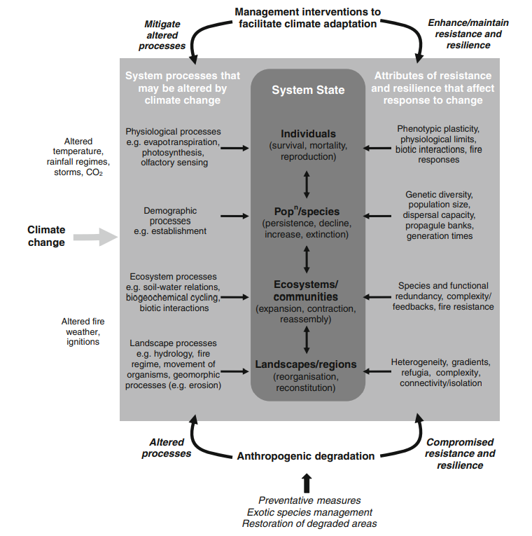

**Figure 7.** Prober et al. (2011) Change-resilience framework for appraising climate change impacts and adaptation interventions in a given biome or region. Any such system comprises interacting elements at different levels of organization, from individuals through populations and species to ecosystems and landscapes. Note that many of the processes in the framework interact in complex ways and may act at multiple levels in the system; for simplicity, these interactions are not shown.

Since vegetative structure drives abundance of bobwhite and other wildlife (and impacts livestock) reoccurring heatwaves and persistent, long-term drought in grasslands is a significant concern, as are wildfires in grasslands and savannas. As a species whose survival strategy is dependent on high reproduction rates, 25% of annual production of bobwhite has been linked to precipitation. Furthermore, bobwhite are very sensitive to extremes in temperatures. Providing good quality, networked habitats across landscapes is our best option to mitigate the effects of climate change. In an analysis of risk versus feasibility of climate change adaptation approaches, Prober et al. (2011) concluded that “*prevention or restoration of human-induced degradation…formed the set of lowest-risk options, with likely benefits for biodiversity independent of the extent and direction of climate change*.” In short, habitat restoration is a low-risk option with potential for significant success regardless of any continued uncertainties regarding future of climate change rates.

**Altered Disturbance Regimes**

Grasslands and savannas are fire adapted systems and many endemic species in these systems are fire dependent, needing fire to reduce competition and trigger germination. Fire fundamentally influences community structure and composition. Suppression of fire can have deleterious and long-lasting negative effects, including loss through conversion to non-natives, woody-conversion of grasslands, or invasive plants dominance that eliminates wildlife forage. Likewise, longleaf pine grown for commercial use is dependent on regular cycles of burning for optimal market growth. WLFW will increase the use of prescribed fire on private lands through technical and financial assistance to offset fire suppression, creating and maintaining openness to benefit ecosystem health and timber values. NRCS will develop conservation plans for private lands that recommend prescribed burning every two years to encourage herbaceous-vegetated understories and tree growth in savannas, and reduce woody encroachment in grasslands and savannas. Growing season burns will be prioritized during the project planning and ranking process. Additionally, WLFW has new (FY22) partnership agreements to hire field staff to assist private landowners in establishing landowner-led Prescribed Burn Associations to plan and execute prescribed burning in the Southeast.

WLFW is also funding landscape planning to improve fire management in the Southeast. NRCS funded and managed development of the **SE FireMap** **beta version 1.0** released in March 2021 ([Wildland Fire (landscapepartnership.org)](https://landscapepartnership.org/key-issues/wildland-fire). The primary objective of the tool is to develop a cohesive system using remote sensing to track both prescribed fires and wildfires across the Southeast, providing significantly improved resolution over other regional and national systems currently in use. Version 2.0 of the **SE FireMap** will be released in 2022. A decision support tool based on merging the **LEO GDB** and **SE FireMap** is planned for 2023 and will be available on this same web portal (to view all content and access data downloads, please register on the home page).

**Figure 8.** Growing season burns are most effective at suppressing the growth of invasive woody vegetation and encouraging growth of grasses and herbaceous vegetation for wildlife forage. Timber growth also benefit most from growing season burns.

“*Family forest owners take on a tremendous amount of responsibility in managing their forests in an ecologically and economically sustainable manner. Their hard work helps them achieve their objectives of income, recreation, legacy and more. However, society at large are the true benefactors from all of the forest values produced from this hard work including clean air and water, forest products, and diverse and abundant wildlife that is essential to our health and lifestyle. USDA’s Working Lands for Wildlife supports landowners in their journey as they become aware of the values they steward, understand how to produce higher quality values and ultimately to take action through long term management.”* **Chris Erwin, Director, Biodiversity and Southern Conservation, American Forest Foundation**

**Invasive Species**

NRCS will increase use of vegetation management to manage growth of native and non-native plants on private lands. Assistance for mechanical brush management will be provided in conjunction with prescribed burning to reduce high fuel loads, making burning safer and more effective at controlling undesirable woody vegetation and enhancing herbaceous groundcovers. In all landscapes, controlling undesirable and invasive plant species will be a priority through brush and weed management, including mechanical and chemical control techniques. Southeast grasslands have some of the highest endemic plant diversity in the world and managing invasive vegetation will help conserve these if planning includes consideration of existing native plants and native seed banks. Partnerships and local job sheets will be developed to guide these considerations.

**[pic of brush management]**

**CONSERVATION ACTIONS**

**Priority Conservation Actions and Goal setting**

In May of 2021, the twenty-four participating NRCS state offices were asked to identify which conservation practices they would be using in their state to support the national WLFW Northern bobwhite, Grasslands and Savannas initiative. Nationally, we have a list of 44 potential practices and each state narrowed that list to those practices most applicable to their resource concerns and landowners’ interests. The NRCS state offices and their local partners set goals for selected practices for fiscal years 2022-2026 to be implemented within priority areas in each state (Figure 2). Funding support for practices have primarily been through the Environmental Quality Incentives Program funds managed by each state, however over time we hope to attract a variety of funding support to ensure “stretch” goals are met to grow the state efforts beyond current outputs. Prescribed Grazing and Brush Management were the most prevalent practices nationwide, followed by Prescribed Burning, Herbaceous Weed Control. All other practices totaled less than 5% of planned implementation when averaged across all states. Looking regionally gives more clarity to the suite of practices deemed most effective for varying land uses and systems.

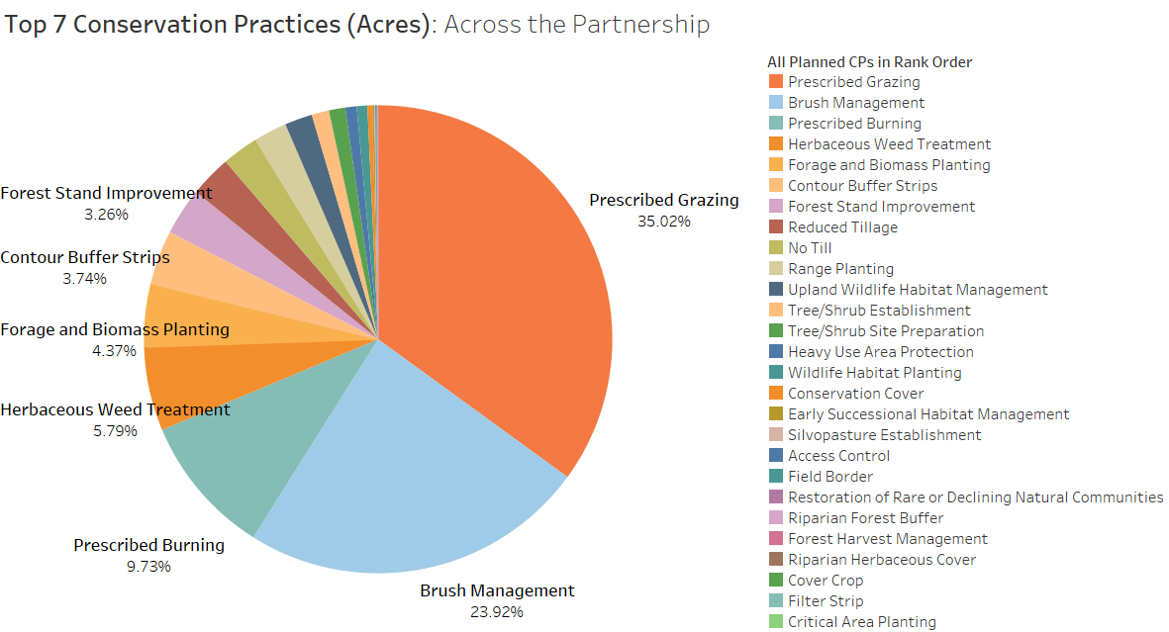

**Figure 9. Top 6 Conservation Practices to be Employed Nationwide**

The goals for this initiative have been consolidated by NRCS regions (Figure 10). 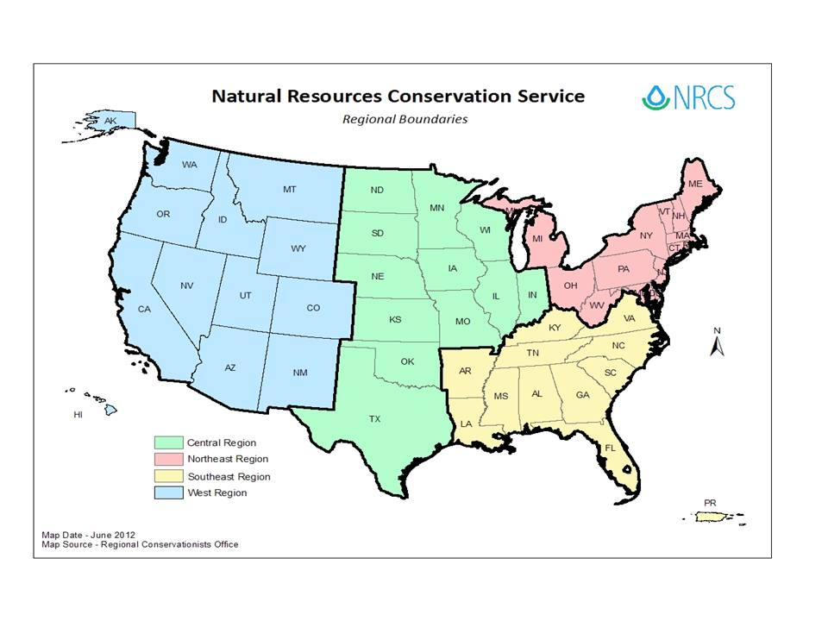

**Figure 10.** Map of NRCS regions. [is there an updated agency map?]

In the **Central Region**, Prescribed Grazing comprised almost 70% of the states’ cumulative goals. Other top practices focused on planting forage in rangelands/pastures or reduced tillage practices in crop fields. Northern bobwhite and other wildlife species are highly compatible with grazing as long as a quality prescribed grazing conservation plan is followed. Restoring native forage in areas previously converted to non-native grasses greatly enhances wildlife values, even when enacted on a portion of an ag operation.

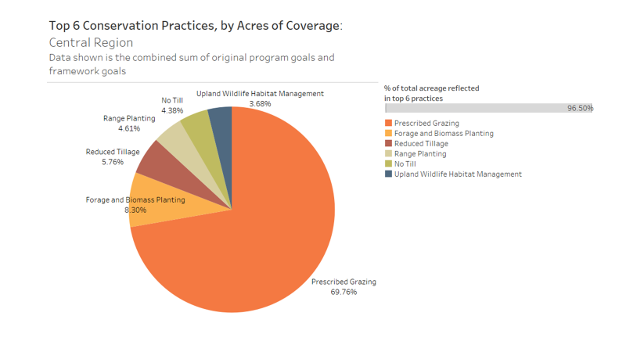

**Figure 11.** Top Conservation Practices in the Central Region [reformat image]

In the **Northeast Region**, the top two practices were Forest Stand Improvement (thinning timber stands) and Prescribed Burning which also clears out overgrown middle and understories. When woody and invasive vegetation crowd under and mid-stories, timber values and wildlife habitat are negatively impacted. Most complementary practices focused on reestablishing native vegetation on managed sites through practices like Wildlife Habitat Planting and Forage and Biomass Planting. Prescribed Grazing was included but not a dominant practice in the Northeast.

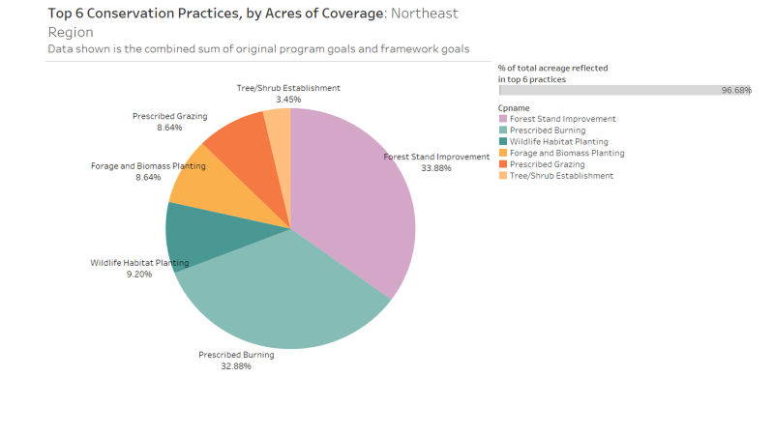

**Figure 12.** Top Conservation Practices in the Northeast Region [reformat image]

In the **Southeast Region**, Prescribed Burning heavily dominated implementation goals. As in the Northeast, Forest Stand Improvement was also heavily used in the Southeast. Other practices represented single digit percentages of the total goals. The Southeast leads the nation in prescribed burning, and with generally wetter conditions than out West prescribed burning is the preferred method for controlling invasive vegetation and reinvigorating habitat values. Forest Stand Improvement has both wildlife and timber production benefits. Burning and thinning creates space that maximizes growth of high quality timber.

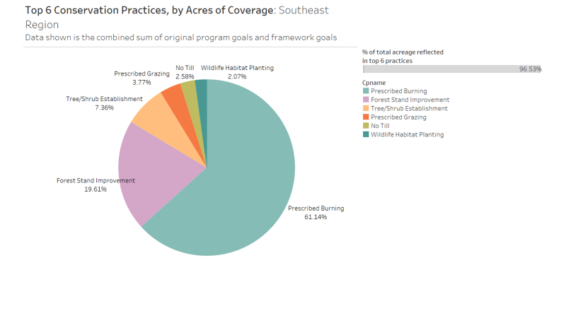

**Figure 13.** Top Conservation Practices in the Southeast Region [reformat image]

**Easement and Stewardship Programs**

Grassland easement programs and the Conservation Stewardship Program (CSP) are not currently widely used to achieve conservation in many of the participating states, and there is a lot of room for growth in this area as these programs catch on with staff and landowners. Of the two, CSP is more widely used with nine states proposing to conduct 165,000 acres of CSP contracts focused on grasslands and savannas. CSP incentive payments can be quite significant and we’re anticipating significant growth in CSP sigh-ups. Easement goals under the Agricultural Conservation Easement Program were set by six states but only totaled 3,200 acres. All NRCS programs are voluntary and easement program participants can benefit financially from their participation as well as have security that their family property will remain in a rural land use.

**Anticipated Outcomes Resulting from Goal Achievements**

Circling back to why NRCS has made this initiative a priority, our umbrella species the Northern bobwhite quail has been documented to be in severe, long-term decline in the U.S. Following the paradigm of Westwood et al. (2014) and the 5-stage classification of recovery, we’ve now discussed the diagnosis of resource concerns and treatments through conservation planning and practice implementation; our longer-term goals are to stabilize existing habitat, rehabilitate grasslands and savannas, and recover native wildlife and plant species to achieve improved systemic health, less risky and more profitable agricultural operations, and greater resilience in the face of changing climatic conditions.

The National Bobwhite Conservation Initiative has estimated that a minimally viable population of Northern bobwhite is comprised of 800 birds, then based on the area size to support that number they derived a minimal landscape size or “focal area” of 1500 acres with at least 25% of each focal area actively managed for bobwhite. Based on these assumptions, NBTC and the University of Georgia established the Coordinated Implementation Program (CIP) monitoring sites throughout the range, anchored by managed state-owned lands. CIP monitoring indicates that bobwhite populations are mostly stable in those managed landscapes. WLFW will seek to establish additional focal landscapes throughout the states’ priority areas for this initiative to rehabilitate habitat and recovery bobwhite populations.

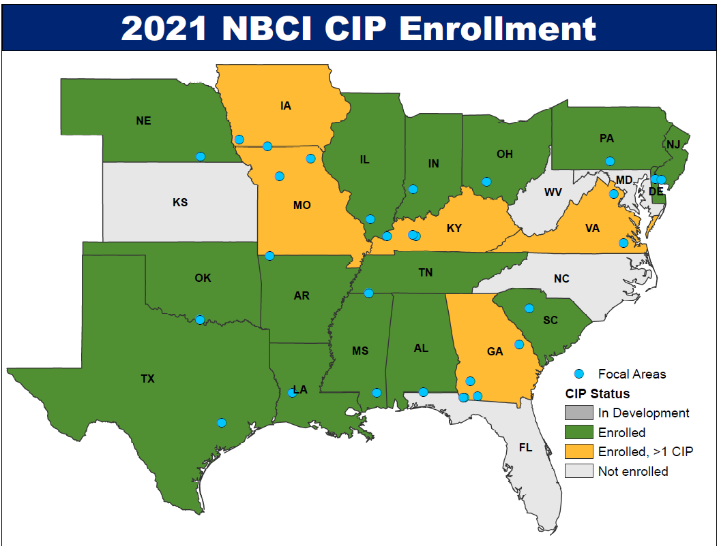

**Figure ##.** Map of enrolled and pending CIP sites established to monitor progress in conservation of Northern bobwhite.

We asked a group of species experts to evaluate the conservation practices proposed in this framework and evaluate the benefits to Northern bobwhite in terms of the four primary habitat needs discussed earlier. Figure ## displays the consensus opinion of those experts regarding which conservation practices will enhance specific bobwhite habitat needs. It is critically important that in each landscape where bobwhite occur, all four habitat needs are met. As a non-migratory species, the size of managed sites and landscape context both matter greatly to bobwhite.

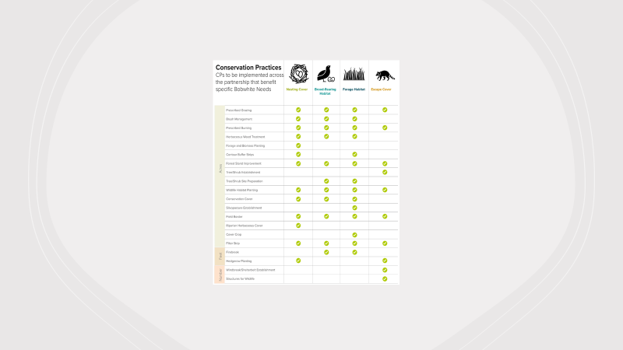

Figure ##. Anticipated direct benefits to Northern bobwhite populations from Farm Bill conservation practices. [reformat image and increase size to ½ page in document]

"*It's been amazing to carry out this 5-year plan with the conservation partners. Almost 40 years to the date, we went without any quail here. We didn't see them; we didn't hear them. And just this past Memorial Day weekend, my brother-in-law and I were outside doing some work and we heard some quail right here in these pine trees. Of course, we were ecstatic! But it really demonstrates the point that in less than 3 years' time, that we have been able to work with these partners in conservation, after a 40-year absence, a species has returned. We couldn't be happier.* " Austin Klais, Coordinating Wildlife Biologist, Pheasants Forever, Inc. and Quail Forever, Louisiana; (See also [https://youtu.be/ZDCqkf_kx7U](https://gcc02.safelinks.protection.outlook.com/?url=https%3A%2F%2Fyoutu.be%2FZDCqkf_kx7U&data=04%7C01%7C%7Cdbd73550d30444672c6308d94bbc55a8%7Ced5b36e701ee4ebc867ee03cfa0d4697%7C0%7C0%7C637624094526477063%7CUnknown%7CTWFpbGZsb3d8eyJWIjoiMC4wLjAwMDAiLCJQIjoiV2luMzIiLCJBTiI6Ik1haWwiLCJXVCI6Mn0%3D%7C1000&sdata=XJ%2BDTBa6jQcayRWfJqISUWKYf4Ir7hEIcEPbVM9cvdI%3D&reserved=0))

Figure # lists the practices that expert tagged as contributing to establishment of each of the four primary habitat needs of bobwhite, while many practices can support multiple habitat requirements. Given here also are acreage estimates for each habitat category over the 5-year planning period of this framework planning document.

.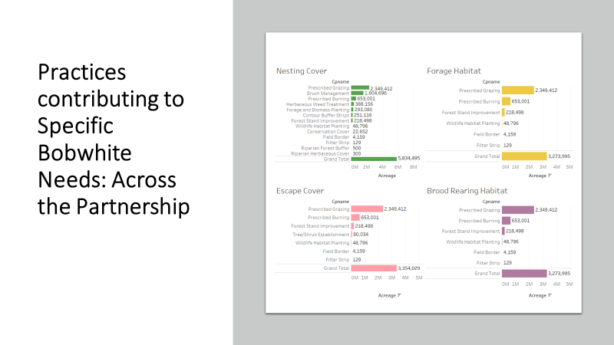

**Figure 16.** Primary conservation practice goals for each of four categories of Northern bobwhite essential habitat components. [reformat image and/or increase size to ½ page]

**Economic Benefits to Agricultural Operations: Risk Management**

A basic tenet of Working Lands for Wildlife is that our implementation supports the continuation of working landscapes and enhances ag operations and rural economies. Therefore, it was key to carry this forward within the Northern bobwhite, Grasslands and Savannas initiative by evaluating the contribution that implemented conservation practices might collectively have on the inherent risks experienced by ag operations (e.g., drought, wildfire) and on enhancing farm income and ag economies (e.g., improving forage, sustaining huntable wildlife). We sent a survey to an expert group of USDA economists, foresters, grazing specialists to give us insight into how our practices could in turn benefit local economies. In Figure #, 5,384,000 acres of conservation practices will contribute to mitigating nine risk factors for farmers, ranchers and forest landowners are depicted in bar graphs. The top risk mitigation practice was Prescribed Burning, which can greatly reduce both the risk of wildfires, their extent, and how destructive and dangerous they are. Other beneficial practices benefited both water quality and quantity, reduced soil erosion and improved overall soil health. Drought mitigation was also a significant benefit for producers. Reducing risks is key to maintaining financial stability.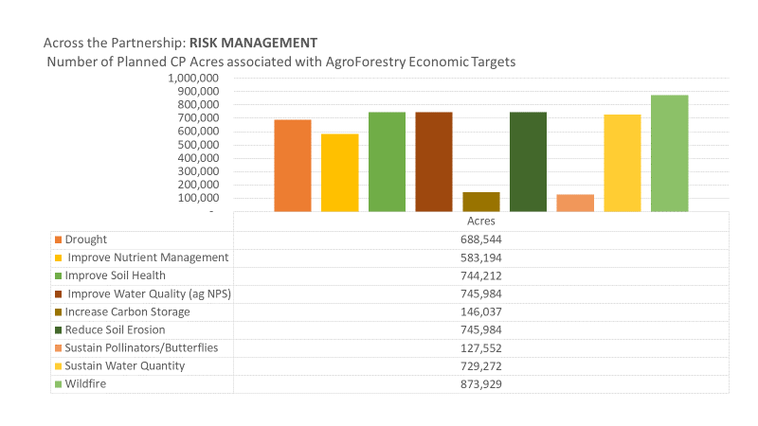

**Figure ##.** Graph depicting the contribution of the Northern bobwhite, Grasslands and Savannas initiative to reducing nine primary economic risks of agricultural operations. [reformat image; put these in rank order in bar graph and delete acres listed]

**[a quote from row crop farmer]**

**Economic Benefits to Agricultural Operations: Revenue Enhancement**

Beyond controlling economic risks, other conservation practices directly enhance producer revenue. Improving forage or commodity quality increases the value of products and thus annual income. By increasing wildlife habitat quality, hunting leases or wildlife viewing tours present opportunities for revenue for individual landowners, and in areas where these practices are concentrated to create niche markets. Additionally, conservation of non-game can contribute to recovery of at-risk, threatened, or endangered species and lead to lessening regulation of private lands. Greater access to carbon markets can also be achieved individually through specific conservation practices and collectively in a region where groups of landowners create their own opportunities to participate in carbon credit sales. In total, almost **six million acres** of conservation practices implemented under this framework will contribute to revenue enhancement for USDA participants! [Also include this last sentence in a text box]

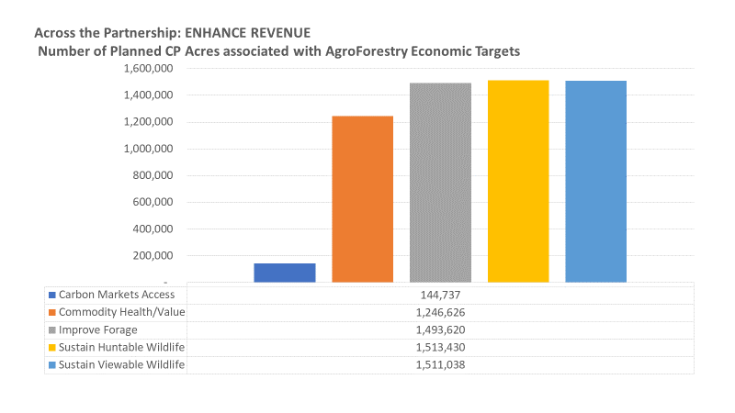

**Figure #.** Conservation practices that benefit wildlife can have dual and important benefits to enhancing agricultural revenue, the essence of WLFW.

**Climate Change Mitigation: Greenhouse Gas Reductions**

As mentioned earlier in this document, NRCS has identified twenty-seven conservation practices that measurably contribute to reduction in greenhouse gases (GHG), and therefore mitigate climate change impacts. Within this framework, 3,651,178 acres will be treated with practices that reduce GHGs emissions across three categories: agroforestry, soil health, and pasture and rangelands. Work is underway at NRCS to also identifies conservation practices that can be quantified as to their level of effectiveness toward climate adaptation, “the process of adjustment to actual or expected climate and its effects” (IPCC 2014). USDA participants will increasingly find that Farm Bill programs can assist them in adapting their operations to climate change and building greater resilience to those changes. Once the new list of measurable climate adaptation practices is available, NRCS will conduct a secondary assessment of contributions to climate adaptation made through practice goals established for the Northern bobwhite, Grasslands and Savannas work and that will also be shared with partners and the public.

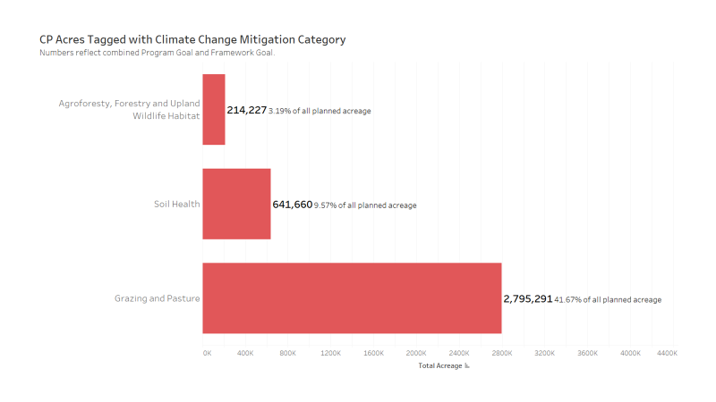

Figure #. Conservation practices in this plan that contribute to GHG reductions total over 3.5 million acres. [reformat this graphic]

**Conclusion**

This Framework for Conservation Action represents a significant acceleration in the involvement of NRCS in conservation of grasslands and savannas, Northern bobwhite, and other co-occurring species. It also represents a demonstrable shift to better assess the economic and climate change implications of Working Lands for Wildlife-led conservation initiatives.

The national bobwhite partnership has been strong for decades and NRCS has always been a strong partner. What Working Lands for Wildlife can now contribute are improvements in coordination across the vast distribution area of Northern bobwhite, increases in both financial and technical assistance needed to reverse declining bobwhite trends, and applied science to measure and improve outcomes. Because bobwhite is an umbrella species, we anticipate significant benefits to other grassland and savanna species, and a regional monitoring plan will be executed to measure outcomes for these as well.

“*NRCS has been a steadfast partner of the NBCI for decades. Our shared vision of blending food and fiber production with conservation and sustainability on America’s working lands will keep us together for decades to come*.” John Morgan, Director, National Bobwhite Conservation Initiative

Northern bobwhite populations have followed declining trends in grasslands and savannas in the Central and Eastern U.S. The health of these systems is being “reported” to us through the plight of the species that live there. The losses have been significant, remember 90% of grasslands in the Southeast are lost or degraded with a comparable 80% decline in bobwhite populations. Our hope is that this renewed effort led by WLFW, and the almost 7 million acres of conservation practices that will be delivered by NRCS and its partners from 2022-24, will light a proverbial fire that results in measurable recovery of these natural systems and declining wildlife over time. It has taken years for these declines to become so alarming, and it will take many years to dig back out of these deep holes we’ve dug. For the most part, experts and landowners both know what to do but we have not collectively been doing enough. This framework represents a renewed effort by NRCS to jump-start recovery of these systems and a commitment by WLFW to assist partners and our USDA clients in achieving success.

REFERENCES: [needs to be cleaned up!]

Kenneth V. Rosenberg1,2*, Adriaan M. Dokter1 , Peter J. Blancher3 , John R. Sauer4 , Adam C. Smith5 , Paul A. Smith3 , Jessica C. Stanton6 , Arvind Panjabi7 , Laura Helft1 , Michael Parr2 , Peter P. Marra8, 2019. Decline of the North American Avifauna. Science

Crosby et al (2015) Looking beyond rare species as umbrella species: Northern Bobwhites (Colinus virginianus) and conservation of grassland and shrubland birds

Andrew D. Crosby a,⇑, R. Dwayne Elmore a, David M. Leslie Jr. b, Rodney E. Will a Elsevier Ltd.

Journal home page for Trends in Ecology & Evolution

Science & Society

Is conservation triage just smart decision making?

Author links open overlay panelMadeleine C.Bottrill1Liana N.Joseph1JosieCarwardine1MichaelBode1CarlyCook1Edward T.Game1HedleyGrantham1SalitKark12SimonLinke1EveMcDonald-Madden1Robert L.Pressey13SusanWalker4Kerrie A.Wilson1Hugh P.Possingham1

<https://doi.org/10.1016/j.tree.2008.07.007>

Climatic Change (2012) 110:227–248 DOI 10.1007/s10584-011-0092-y Facilitating adaptation of biodiversity to climate change: a conceptual framework applied to the world’s largest Mediterranean-climate woodland Suzanne M. **Prober**· Kevin R. Thiele ·Philip W. Rundel· Colin J. Yates· Sandra L. Berry · Margaret Byrne ·Les Christidis· Carl R. Gosper· Pauline F. Grierson · Kristina Lemson ·Tom Lyons· Craig Macfarlane · Michael H. O’Connor· John K. Scott· Rachel J. Standish ·William D. Stock

USDA Working Lands for Wildlife. 2018. Economic and Production Performance of Grazing Native Grasses in the Fescue Belt. 4spp. nrcs.usda.gov/wildlife.

Strickland, J.R., M.L. Looper, J.C. Matthews, C.F. Rosenkrans Jr., M.D. Flythe, and K.R. Brown. 2011. “St. Anthony’s Fire in Livestock: Causes, Mechanisms, and Potential Solutions.” Journal of Animal Science 89:1603-1626.

Conserv Biol

. 2009 Oct;23(5):1080-9. doi: 10.1111/j.1523-1739.2009.01264.x. Epub 2009 Jun 22.

A review of climate-change adaptation strategies for wildlife management and biodiversity conservation

Jonathan R Mawdsley 1, Robin O'Malley, Dennis S Ojima

Facilitating adaptation of biodiversity to climate change: a conceptual framework applied to the world’s largest Mediterranean-climate woodland Suzanne M. Prober· Kevin R. Thiele ·Philip W. Rundel· Colin J. Yates· Sandra L. Berry · Margaret Byrne ·Les Christidis· Carl R. Gosper· Pauline F. Grierson · Kristina Lemson ·Tom Lyons· Craig Macfarlane · Michael H. O’Connor· John K. Scott· Rachel J. Standish ·William D. Stock · Eddie J. B. van Etten · Grant W. Wardell-Johnson · Alexander Watson Received: 31 January 2010 / Accepted: 25 February 2011 / Published online: 21 June 2011 © Crown Copyright 2011

Ross et al. For each threat, workshop participants identified science and information needs, including database availability, research priorities, and modeling and mapping needs.

IPCC 2014